Exercise:
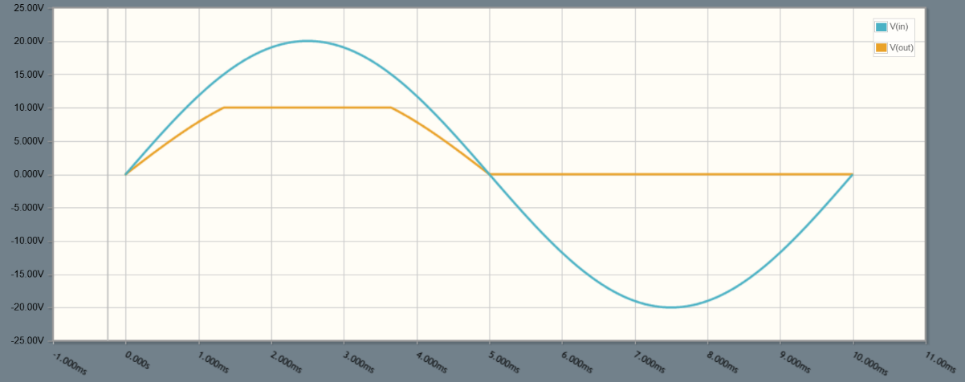
- Draw approximately the output voltage $V_{out}$ for the first period, and precise the time and voltage values knowing that $R=5 kΩ$ . (1 point)

We replace the resistor $R$ with a capacitor $C=1 μF$ :
- Draw approximately the output voltage $V_{out}$ for the first period. (2 points)
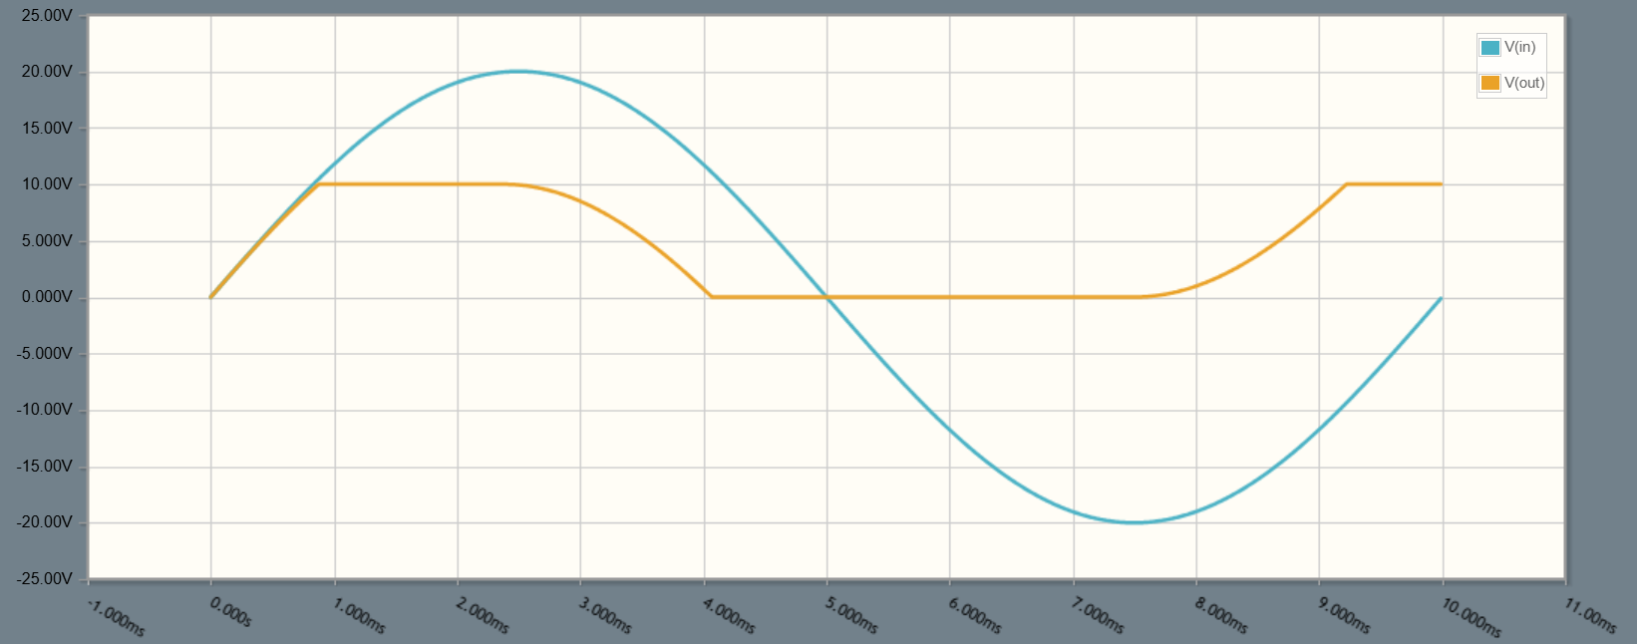
- Indicate below your graph the intervals when the capacitor is charging and discharging. (0.5 point)
discharging
discharging
charging
inversed polarity
charging

For the voltage source $V_{in}$ with an amplitude of $15V$ and a period $T=20ms$, and for the same output load $R_{L}$ :
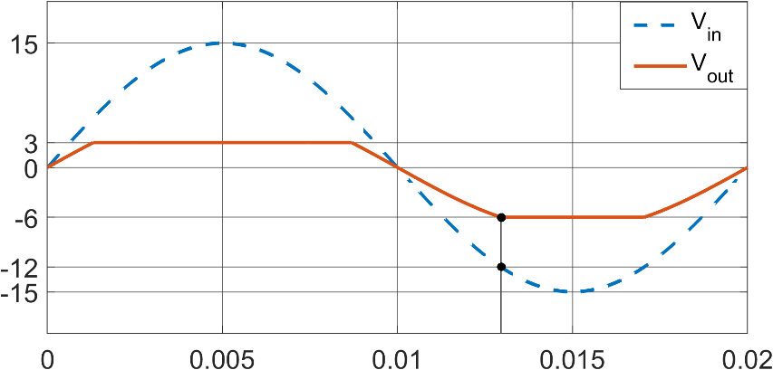
- Draw the circuit that gives the following output voltage. Precise the value of each element. (1 point)

